O.M.C.
  - Ohio Monthly communicator
  - Proudly Serving the HH / deaf community
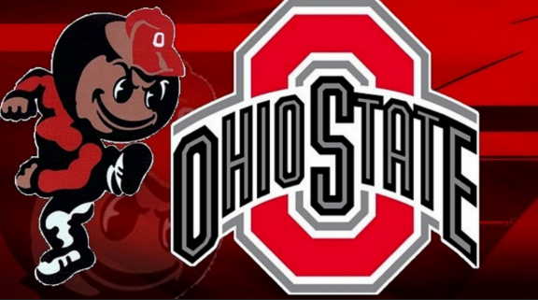
Ohio State Buckeyes
Why we are here  Welcome to what we envision as a transformative moment for our community!  Our mission is to educate and improve the quality of life for individuals while promoting accessibility and inclusion throughout the community.  This monthly Newsletter will act as a hub to keep our community connected. | did you know?  Ohio State University offers ASL classes and an ASL Minor? And OSU has an active Deaf/HH student organization that invites the community to join their events!  Read on to discover a bit of information about DHOSU’s student leaders. | Featuring Famous deaf People From Ohio  Judith Scott  Sue Thomas  Thomas Edison
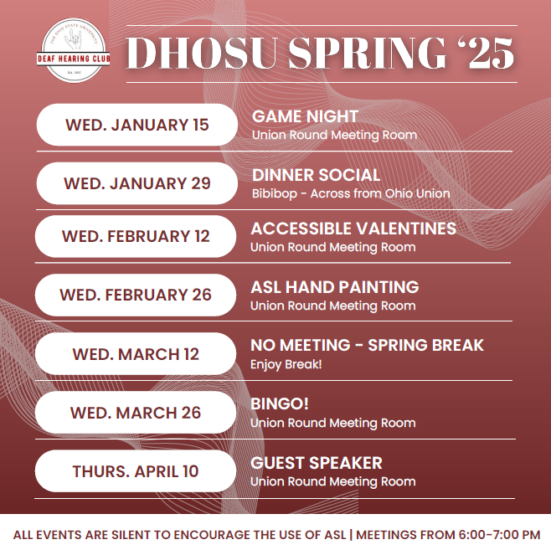
O.M.C. Welcomes Olivia Tull (President) and Marleigh Winterbottom (VP) of the Ohio State University’s Deaf-Hearing Club. Located at 1739 North High St. (3rd floor)

Club Overview:
What is the name of the club?
The Deaf-Hearing Club at Ohio State University.

Can you tell me about the mission and goals of the club?
To bring people of all ages and all levels of fluency in ASL, within and outside of OSU, through social activities, and educational seminars that affiliate with the Deaf Community and/or the use of American Sign Language. We aim to foster community and connections between the Deaf community and OSU ASL students.

Membership and Participation:
1. How many members does the club currently have, and what are the demographics of the members?

We typically have 15-30 people at our meetings. The majority of our members are OSU ASL students ranging from beginner learners to more advanced signers. We also have some Deaf membership between students, faculty, and community members that we are hoping to grow.

2. What types of activities or events does the club organize to engage members?

DHOSU hosts a collection of biweekly social and educational events for members to interact in ASL, encourage Deaf awareness, and create community. Regular events that we hold include Game Nights, Dinner Socials, and Accessible Valentines Craft Night (for CCEC). We have also held other events including a community CODA showing and discussion, an ASL Interpreter Panel, ASL Hand Painting, Bingo Night, and an ASL Poetry Slam.

Learning and Teaching Sign Language:
1. What resources do you provide for members who are new to sign language?

While DHOSU is not an ASL-teaching club, we provide a space for students and community members to learn from each other and practice conversational skills. Since our meetings are silent events to promote an ASL-inclusive environment, we provide support for all of our meetings for beginner signers through the use of visual supports, writing, and the display of simple signs that would be helpful for our activity. We prefer to leave more formal ASL teaching to the Deaf community and OSU ASL courses, but we, as a club, aim to provide adequate support and resources to those still learning and developing their skills to allow everyone to follow along and be included in every meeting.

2. Can you describe any challenges that beginners typically face when learning sign language?
Challenges that beginners tend to face when learning ASL include following longer ASL conversations and/or discussions and expanding their own use of ASL to hold casual conversation on a variety of topics.

Community Involvement:
- How does the club engage with the wider community?

DHOSU aims to participate in the greater Columbus Deaf community, and we have held events including volunteering at OSD’s [Ohio School for the Deaf] annual Fall Fest and Trunk or Treat and we extend invitations to the community for larger events such as our CODA movie screening and discussion and our ASL Interpreter Panel.

Personal experience:
- What inspired you to get involved with the sign language club?

Marleigh: I joined DHOSU because I wanted a place to practice my ASL skills and keep up with my signing in semesters when I was not taking an ASL course. I was excited by the opportunity to sign with Deaf students/community members and enjoyed the ability to connect with other students through social events. My continued membership has increased my ASL skills exponentially and helped me be more comfortable in casual conversation, ASL expansion, and interacting with Deaf signers.

Olivia: I joined DHOSU to continue having the ability to use and improve my ASL skills. I really enjoyed learning ASL in high school and being a part of my high school’s organization, so I knew I wanted to continue taking ASL classes and participating in Deaf community events in college. I think what really kept me involved with DHOSU was the opportunity to join the leadership team. Both Marleigh and I joined the board during our first semester, and it’s been quite formative for our college experiences. Since joining DHOSU over two years ago, my signing has greatly improved, in addition to my confidence and interpersonal skills to interact with new individuals, whether Deaf or hearing using ASL.

Future Plans:
1. What are some upcoming initiatives or projects the club is planning?

Our biggest goal currently is to increase Deaf membership and attendance. With a goal of creating a community of Deaf individuals and ASL learners, we appreciate any and all Deaf involvement and pride ourselves in making sure every meeting is Deaf-accessible. We also aim to hold more educational and community/guest speaker events to expand our members’ knowledge and understanding of Deaf culture and the local community.

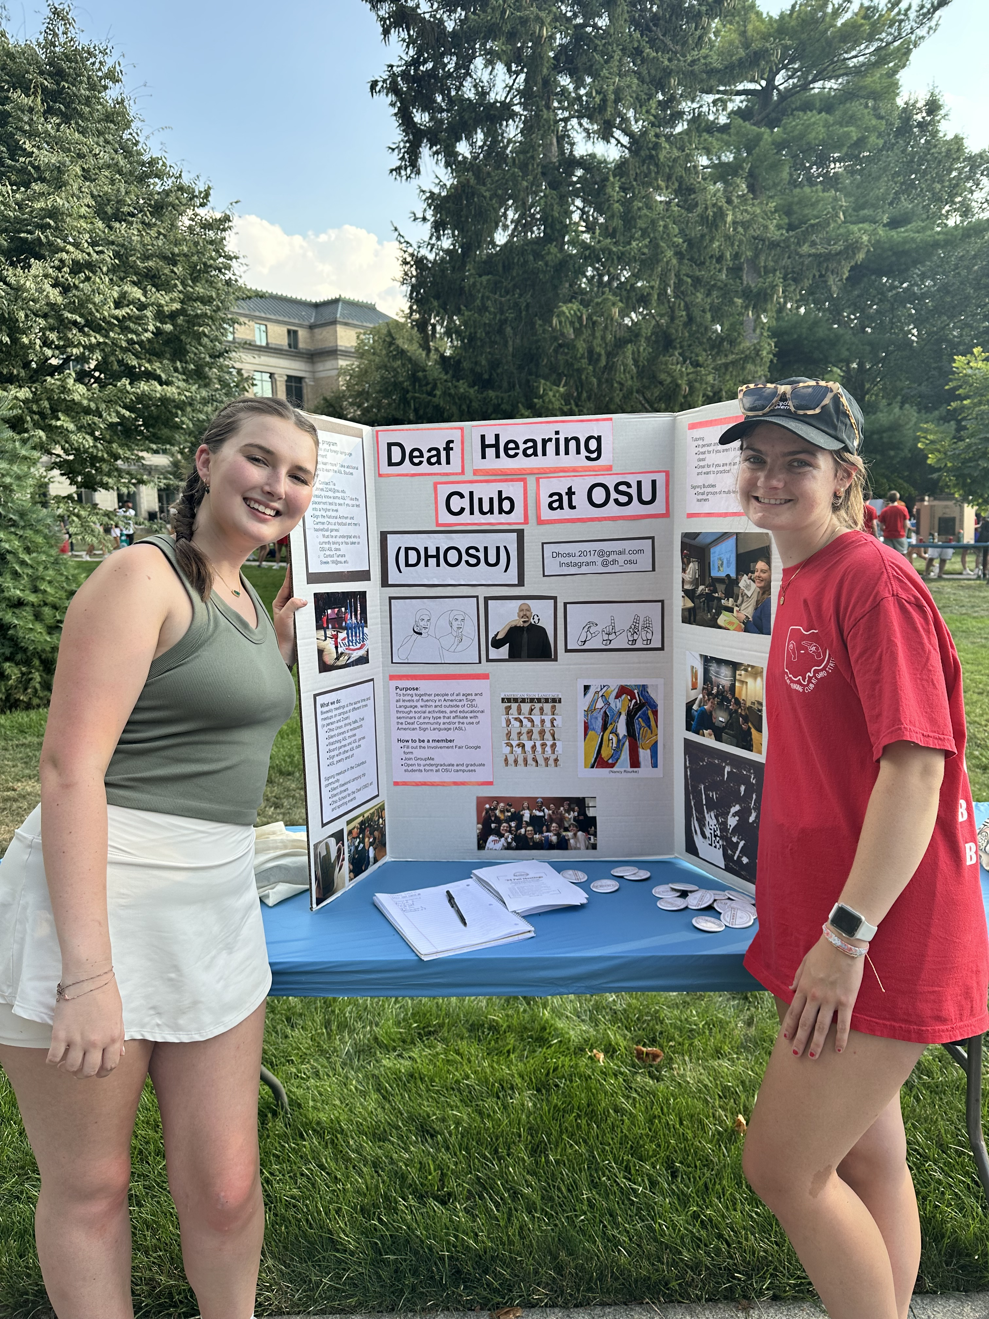
(L) Marleigh Winterbottom (R) Olivia Tull

2. How do you envision the club evolving in the next few years?

In the next few years, we envision the club increasing regular membership attendance and increasing in membership size more generally. We hope to have a greater representation of Deaf membership and to bring Deaf members onto our executive board for further meetings and event input from the Deaf community.

Impact:
- Why is learning sign language important, in your opinion?

Marleigh: In my experience, learning sign language has reshaped how I think about accessibility and communication. It has opened my eyes to the barriers that exist in everyday environments and has made me much more aware of the access issues that many people face and how I can work to increase accessibility within my own spaces. Sign language has also expanded my understanding of what communication can look like and helped me appreciate the diversity of how people can connect and express themselves. This perspective has especially impacted how I view my future career in Speech-Language Pathology and motivated my commitment to specializing in alternative communication methods, focusing on language inclusion and advocating for accessible communication in all forms such as ASL, AAC, etc.

Olivia: Learning sign language has changed my life. After taking my first sign language class, I learned about Deaf culture and how ASL and other sign languages are so much more than just a language. They are also a community and way of life, and learning about the experiences and insights of the Deaf community has been eye-opening as someone looking to pursue medicine in the future. I originally began learning sign language as I hoped to be able to communicate with more diverse patient populations. As I learned more from Deaf individuals about the systemic barriers they face in healthcare, my focus shifted. I began to see not just the importance of language access but also the need for advocacy. These experiences ignited my passion for addressing accessibility inequities and ensuring that all patients—regardless of their language—receive the care and respect they deserve.

###
Ohio has been home to several notable deaf individuals who have made significant contributions in various fields:

- Judith Scott: Born in Cincinnati, Ohio, Judith Scott was not only deaf but also had Down syndrome. Despite facing challenges and being labeled as “ineducable,” she became a renowned artist after being introduced to an art school later in life. Her story is one of resilience and creativity.

There are several books that explore the life and work of Judith Scott. Here are a few notable
titles: “Judith Scott, Bound and Unbound,” “The Art of Being,” and “The Art of Judith Scott”

.
- Sue Thomas: Born in Boardman, Ohio, Sue Thomas became deaf at just 18 months old. She developed exceptional lip-reading skills and went on to work as a lip reader for the FBI, contributing to solving many high-profile cases.

Sue Thomas has authored several books that reflect her unique life experiences. Here are a few notable titles. “Silent Night,” “Staying In The Race,” and “Nature and Wellbeing in the Digital Age.”

- Thomas Edison: Although primarily known as an inventor, Thomas Edison was born in Milan, Ohio, and lost his hearing at the age of 12. He is celebrated for his numerous inventions, including the phonograph and the electric light bulb, and holds over 1,000 patents

.
These individuals exemplify the diverse achievements of deaf people from Ohio, showcasing their impact in art, law enforcement, and innovation.

###

As a valued subscriber, your thoughts and preferences are incredibly important to us.

We would love to know what topics you’re most interested in. If there are specific articles or subjects

you would like to see covered in our upcoming newsletters, please reach out!

Feel free to email with your suggestions, and we’ll do our best to include them in future editions.

Your feedback helps shape our content and makes our newsletter better.

Email: SignInMotionWithJeffrey@gmail.com

Designer & Writer: Jeffrey Barbieri
Editor: Nadeane Howard

As a valued subscriber, your thoughts and preferences are incredibly important to us.
We would love to know what topics you’re most interested in. If there are specific articles
or subjects you would like to see covered in our upcoming newsletters, please reach out!
Feel free to email with your suggestions, and we’ll do our best to include them in future editions.
Your feedback helps shape our content and makes our newsletter better.

Email: OhioMonthlyComm@gmail.com

Designer & Writer: Jeffrey Barbieri
Editor: Nadeane Howard

