O.M.C.
  - Ohio Monthly communicator
  - Serving the HH / deaf community

Columbus, OH, Skyline
Why we are here  Welcome to what we hope to be a defining moment in our community. Our mission is to educate and enhance the quality of life for individuals and promote accessibility and inclusion within the community. This monthly newsletter will serve as a place to keep our community connected. | Resources  Deaf services center  This site provides various resources and information for individuals who are deaf or hard of hearing.  Website: deafservicescenter.org. | New technology  Subtitle Glasses by Aircaps could be what some call a “game changer.”  I have been personally testing these glasses and share more info below.
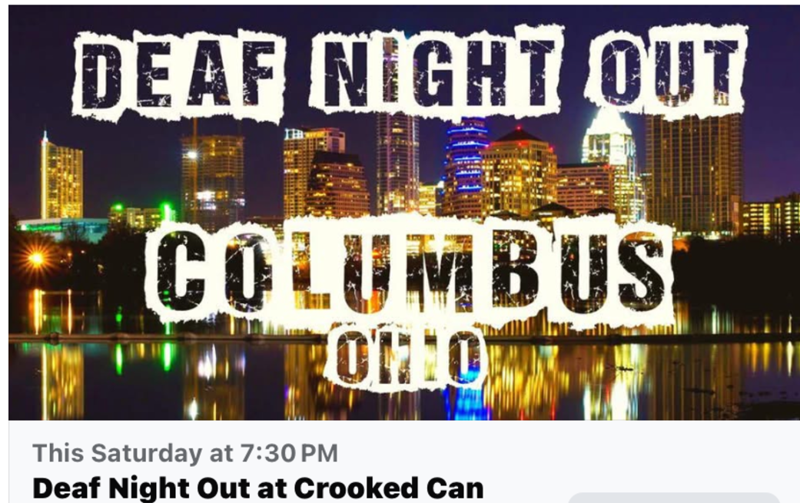
Jan 18th 7:30PM  Crooked Can in Hilliard, Ohio  Why should you come to the Crooked Can?  It's a wonderful opportunity to meet students as well as members of the Deaf Community.  For students, this is an open space to practice what you've learned as well as learn from others with zero judgment. | 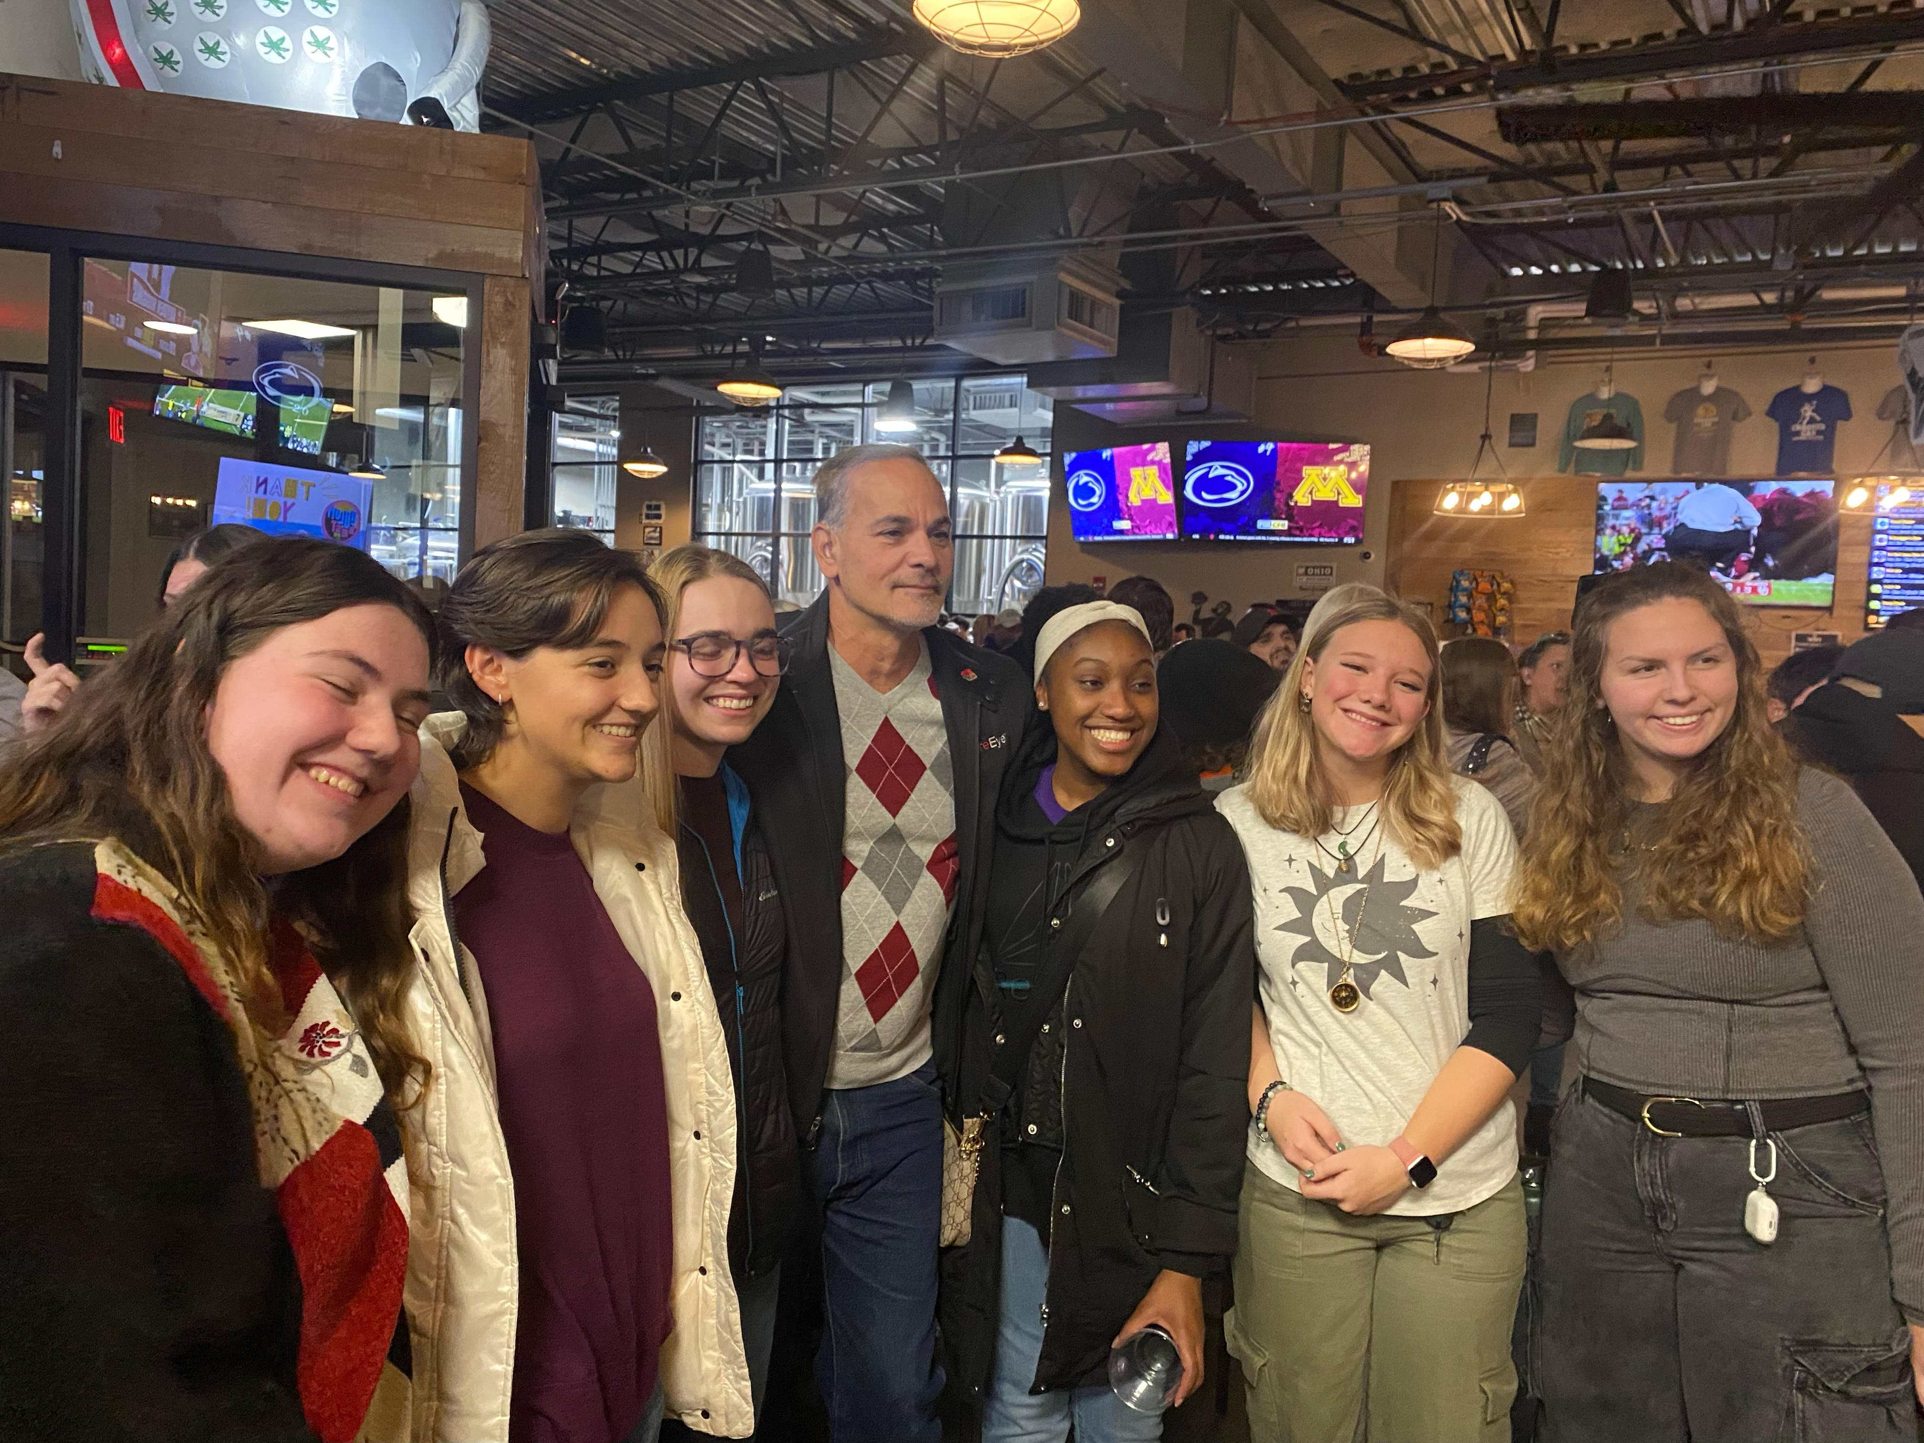

Subtitle Glasses By Aircaps
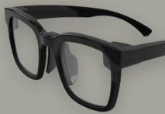
AirCaps has developed smart glasses that display real-time subtitles for conversations. They developed these glasses inspired by loved ones with hearing loss, aiming to make it easier for people to follow conversations and stay connected.

Aircaps claim the subtitles are extremely accurate, and the glasses even work well in noisy environments and with multiple speakers - they can identify & separate individual speakers in group conversations.

The company further claims that many of their early testers have said these glasses are “life-changing” and allow them to feel more connected and involved in conversations they once struggled to follow

You can see more on their website: https://www.aircaps.com/. If you want to get in touch with them, you can email them at aircaps@aircaps.com or schedule a free live demo on their website.

I’ve been testing these glasses for a couple weeks now and will share my experience with them in a future newsletter. If you have tried these, please contact me and share your experience!
As a valued subscriber, your thoughts and preferences are incredibly important to us.

We would love to know what topics you’re most interested in. If there are specific articles or subjects

you would like to see covered in our upcoming newsletters, please reach out!

Feel free to email with your suggestions, and we’ll do our best to include them in future editions. Your

feedback helps shape our content and makes our newsletter better.

Email: SignInMotionWithJeffrey@gmail.com

Designer & Writer: Jeffrey Barbieri
Editor: Nadeane Howard

