O.M.C.
  - Ohio Monthly communicator
  - Proudly Serving the HH / deaf community

Ohio State Buckeyes
Why we are here  Welcome to what we envision as a transformative moment for our community!  Our mission is to educate and improve the quality of life for individuals while promoting accessibility and inclusion throughout the community.  This monthly Newsletter will act as a hub to keep our community connected. | IMPORTANT Dates  March 22nd  National Museum United States Air Force – Interpreted Tours.  March 26th  Deaf Hearing Club @ OSU – ASL BINGO! | Featuring:  Andre’ Brown  Founder: Technical Sparks

The website for the National Museum of the United States Air Force is www.nationalmuseum.af.mil.

This museum, located at Wright-Patterson Air Force Base near Dayton, Ohio, is the world's largest military aviation museum, featuring over 350 aerospace vehicles and missiles, along with thousands of historical artifacts. This is easily a daylong adventure, and it’s perfect for families with children.

- Free Admission and Parking: One of the most appealing aspects is that both admission and parking are free, making it accessible to everyone. And they have free vehicle charging stations close to the building entrance!

- Extensive Exhibits: The museum features over 350 aerospace vehicles and missiles, showcasing the history and technology of military aviation. This includes a wide range of aircraft from different eras, providing a comprehensive look at the evolution of air power

- Historical Artifacts: In addition to aircraft, the museum houses thousands of historical artifacts that tell the story of the U.S. Air Force and its role in various conflicts and peacekeeping missions

- Multiple Hangars: The museum is organized into several hangars, each dedicated to different themes and periods of aviation history. This allows visitors to explore a variety of exhibits in a structured manner.

O.M.C. Welcomes Andre’ Brown, founder of The Technical Spark

What inspired your invention?

The inspiration behind The Technical Spark stemmed from my passion for creating and showcasing electronic components on my YouTube channel. I was originally inspired by the idea of making technology more interactive and accessible. While demonstrating how individual components function, I worked with a sound sensor and used a light as a visual indicator to prove that the sensor was responding accurately to sound. This simple experiment initially served as a technical demonstration, but it quickly inspired me to think beyond just turning on a light.

I realized that this technology could be more impactful, particularly for the deaf and hard-of-hearing community. That realization became a major source of inspiration, pushing me to explore its potential further. Wanting to validate my idea, I reached out to some of my deaf followers on my tech and engineering-focused Instagram and YouTube pages. Their feedback was incredibly inspiring—they not only confirmed its usefulness but also provided multiple real-life scenarios where such technology could significantly improve accessibility.

Their enthusiasm fueled my inspiration even more, leading me to refine the concept and develop five different use cases based on their input. As I continued showcasing the idea, even more members of the deaf community came forward with additional applications, further inspiring me to push this innovation forward. What started as a simple test of a sound sensor became an inspiring journey of discovery, proving that technology has the power to create meaningful change when approached with the right vision.

How did you develop your idea from concept to prototype?

The development of this concept into a functional prototype was heavily influenced by my background in electrical engineering. Initially, I envisioned creating a compact chip that could integrate with components I already owned, allowing the device to capture sound and generate light. Once the core functionality was established, I focused on designing a more efficient power solution. Rather than relying on a fixed wall connection, I optimized the system to be powered via a USB interface, making it compatible with standard phone chargers.

To enhance portability, I selected a smaller chip that allowed the device to operate independently of a fixed power source, enabling it to be used in any setting. This approach provided greater flexibility, ensuring that users could take the device anywhere without limitations.

Beyond functionality, aesthetics also played a key role in the design process. I developed an attractive housing to enclose the components, ensuring a clean, polished appearance while still allowing the device to capture sound effectively. This combination of technical innovation and thoughtful design resulted in a product that is both visually appealing and technologically unique.
Additionally, I implemented custom coding to ensure seamless operation. The system was programmed to function automatically upon being powered, whether through a portable charger or a direct wall connection. This level of integration was made possible by my expertise in both electrical engineering and coding, allowing the concept to transition from an initial idea to a fully developed prototype. Without this technical foundation, the idea may have remained just a concept rather than becoming a tangible, functional product.
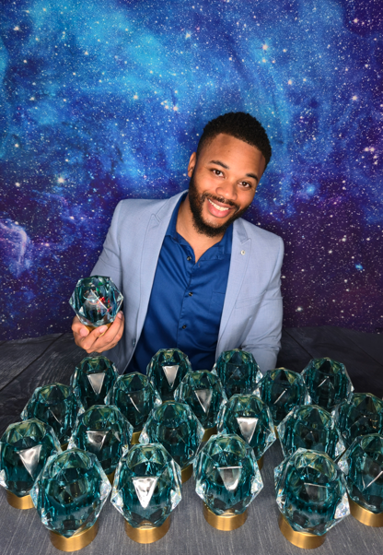
What were the biggest challenges you faced during the invention process?

One of the biggest challenges I faced in developing The Technical Spark was optimizing the sound sensor to accurately detect specific sounds and trigger an electrical pulse. Unlike human hearing, sound sensors can be overly sensitive, often picking up frequencies beyond the audible range, which can lead to inconsistent or unintended activations.

To overcome this, I had to fine-tune the sensor’s sensitivity and implement precise coding to ensure it responded only to sounds within a typical human auditory range. Additionally, I had to establish a reliable detection range of approximately 32 feet, ensuring consistent functionality within a room-sized environment.

Another key challenge was managing how the sensor triggered the electrical pulse. By default, many sound-sensors either remain activated indefinitely once they detect any noise or fail to register subtle variations in sound levels. Through careful calibration and programming, I was able to develop a system that allows the sensor to capture sound, emit an electrical pulse in real time, and deactivate as soon as the sound stops — resulting in a more efficient and controlled response mechanism. This process required a deep understanding of both hardware and software integration, as well as extensive testing to achieve the desired level of accuracy and reliability.
Inventor Andre’ Brown with his Technical Spark

How did you overcome these challenges?

I successfully overcame these challenges by implementing a numerical approach to pinpoint sound detection thresholds. By analyzing the sensor’s ability to detect sound at levels perceptible to the human ear and identifying the point at which detection ceases, I was able to establish precise measurement criteria. This process was then translated into code, ensuring accurate and reliable sound level detection.

Who is your target audience for this invention?

My target audience for Technical Spark is the Deaf/deaf and hard-of-hearing community.

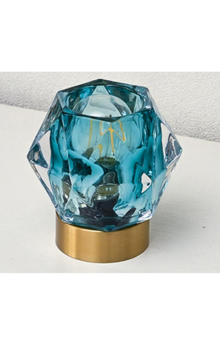
What steps did you take to commercialize your invention?

I have recently captured videos and taken photographs featuring Technical Spark, and I have also received content from other users. I plan to promote all of this content across YouTube, Facebook, and Instagram to engage and expand my audience.

Did you consider patenting your invention?

Yes, I already patented the invention.

Where can consumers purchase your product?

In order to purchase a Technical Spark, please contact me via Instagram or Facebook, or reach out to me directly via email: dretheplug123@gmail.com
The Technical Spark

This will allow you to specify your customization preferences, including the type of light, battery, and housing for your portable device.

Please note that pricing may vary depending on the selected features and specifications. I’ll work with you to ensure your Technical Spark meets your exact needs.

Facebook: Andre’ Brown

Youtube: @Dretheplug

Instagram: Dretheplug123

###
As a valued subscriber, your thoughts and preferences are incredibly important to us.

We would love to know what topics you’re most interested in. If there are specific articles or subjects
you would like to see covered in our upcoming newsletters, please reach out!

Feel free to email with your suggestions, and we’ll do our best to include them in future editions.

Your feedback helps shape our content and makes our newsletter better.

Email: OhioMonthlyComm@gmail.com

Designer & Writer: Jeffrey Barbieri
Editor: Nadeane Howard

